Η πασχαλινή ιστορία
Bunny is an Easter bunny. He is nice and he likes children. Bunny is painting some eggs under a tree. The eggs are beautiful! They are red, and blue and green and purple and orange.
Then Bunny thinks: ‘Let's play a game’ and he hides the eggs in the garden. On the trees, behind the flowers, near the fence, everywhere in the garden.
On Easter day the children come in the garden and look for the beautiful Easter eggs. ‘Where are the eggs?’ they say. ‘There's one on the tree’ says George. ‘There's one behind the flowers’ says Ann. The children find all the eggs.
George, Ann, Mary and Tom are happy. They smile and say: ‘Thank you Easter Bunny! Happy Easter!’
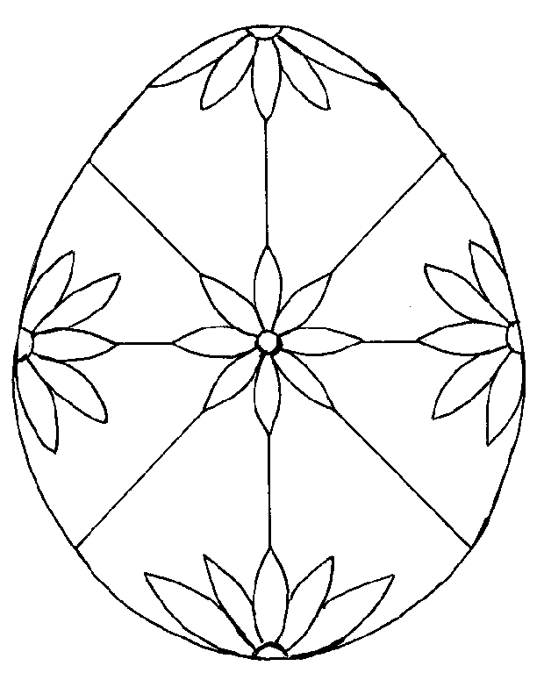
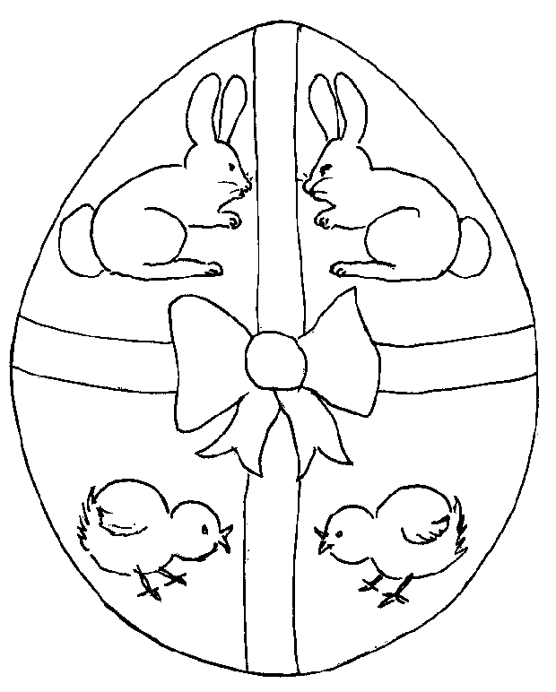
ενδεικτικά σχέδια αβγων
Προτεινόμενες ερωτήσεις
- Who’s this?
- Is this a boy or a girl?
- How many boys/girls/trees etc. are there?
- Has Bunny got a basket?
- What colour are the trees/ flowers etc?
- What is this boy/girl wearing?
- Is there a blue flower in the garden?
- Can the children find the eggs?
- Are the children happy/ sad?
- Are there five eggs in the basket?

Τραγούδι If you like the Easter Bunny
Στο ρυθμό του τραγουδιού «Χαρωπά τα δύο μου χέρια τα χτυπώ»

If you like the Easter Bunny, hop, hop, hop (πηδάμε σαν λαγουδάκια)
If you like the Easter Bunny, hop, hop, hop
If you like the Easter Bunny and you think he's really funny,
If you like the Easter Bunny - hop, hop, hop.

